Ecommerce Store Through Video Moderation

**Ehtisham Zahid**

**Basit Ali**

DEPARTMENT OF COMPUTER SCIENCES

COMSATS UNIVERSITY ISLAMABAD,

ATTOCK CAMPUS – PAKISTAN

SESSION 2019-2023

Ecommerce Store Through Video Moderation

**Undertaking**

*We hereby declare that this software, neither whole nor as a part has been copied out from any source. It is further declared that we have developed this software and accompanied report entirely based on our personal efforts. If any part of this project is proved to be copied out from any source or found to be reproduction of some other. We will stand by the consequences. No Portion of the work presented has been submitted of any application for any other degree or qualification of this or any other university or institute of learning.*

Basit Ali Ehtisham Zahid

--------------------------- ---------------------------

**FINAL APPROVAL**

It is to certify that the final year project of BS(SE) "Ecommerce by video moderation" is developed by Basit Ali CUI/FA19-BSE-031/ATK and Ehtisham Zahid CUI/FA19-BSE-042/ATK under the supervision of “Ms. Sadia Ijaz”. It is fully adequate, in scope and quality for the degree of Bachelor of Science in Software Engineering.

***Committee:***

|  |  |
| --- | --- |
| 1. External Examiner | ____________________________  Examiner Name  Designation  University Name |
| 1. Supervisor | ____________________________  Ms. Sadia Ijaz  Lecturer  COMSATS University Islamabad Attock Campus |
| 1. Head of Department | ____________________________  Dr. Khalid Iqbal  Associate Professor HOD (CS)  COMSATS University Islamabad Attock Campus |

**Acknowledgement**

All praise is to Almighty Allah who bestowed upon us a minute portion of His boundless knowledge by virtue of which we were able to accomplish this challenging task.

We are greatly indebted to our project supervisor “Saida Ijaz”. Without their personal supervision, advice and valuable guidance, completion of this project would have been doubtful. We are deeply indebted to him for his encouragement and continual help during this work.

And we are also thankful to our parents and family who have been a constant source of encouragement for us and brought us the values of honesty & hard work.

Basit Ali Ehtisham Zahid

--------------------------- ---------------------------

**BRIEF**

PROJECT NAME /*

ORGANIZATION NAME /*

OBJECTIVE /*

UNDERTAKEN BY /*

SUPERVISED BY /* SUPERVISOR NAME */

/* DESIGNATION */

/* DEPARTMENT NAME */

/* UNIVERSITY NAME */

Started On /* START DATE */

Completed On /* END DATE */

COMPUTER USED /* NAME OF COMPUTER */

SOURCE LANGUAGE /* LANGUAGE NAME &VERSION */

OPERATING SYSTEM /* NAME OF OS */

TOOLS USED /* NAMES OF TOOLS */

**Abstract**

In modern life the people are moving towards Online shopping. In this project we are making the data readability for user easier by data visualization techniques in our ecommerce store. Video moderation is also important to facilitate the users. The user found in difficulty to search the specific design by just typing in the website search option. To overcome this issue, we are introducing an image option where the customer will upload the picture of that specific product in search bar and he will get the related items to his picture.

This will provide ease to the customer in buying the product also to save his time and avoid frustration. Our System attempts to use image processing techniques to extract the feature and compare it with the items present on the website so the user will get the desired output without much effort. The System will also show the data in an organized way so it will become easy for the customer to read the information easily.

**Abbreviations**

|  |  |
| --- | --- |
| **DFD** | Data flow diagram |
| **CNN** | Convolutional Neural Network |

**Table of Contents**

1. **Introduction** **11**

1.1 Brief………………………………………………………………….. 12

1.2 Relevance to Course Modules 12

1.2.1 Machine learning 12

1.2.2 Video Moderation 12

1.3 Project Background 12

1.4 Literature Review 13

1.5 Analysis from Literature Review (in the context of your project) 13

* 1. Methodology and Software Lifecycle for This Project 13

1.6.1 Rationale behind Selected Methodology 14

1. **Problem Definition** **15**

2.1 Problem Statement 16

2.2 Deliverables and Development Requirements 16

2.3 Development Requirements 16

2.4 Current System 17

1. **Requirement Analysis** **24**

3.1 Use Case Diagram 25

3.2 Detailed Use Case 26

3.3 Functional Requirements 26

3.3.1 Camera 27

3.3.2 PIP 27

3.4 Non-Functional Requirements 28

3.4.1 Efficiency 28

3.4.2 Learnability 28

3.4.3 Robustness 28

3.4.4 Maintainability 28

3.4.5 Reliability 28

3.4.6 Usability 28

3.4.7 Availability 28

1. **Design and Architecture** **29**

4.1 System Architecture 30

4.2 Data Representation [Diagram + Description] 30

4.2.1 DFD LEVEL 0 31

4.2.2 DFD LEVEL 1 31

4.3 Design Models [along with descriptions] 32

4.3.1 Sequence Diagram 32

4.3.2 Activity diagram 33

1. **Implementation** **35**

5.1 Algorithm 36

5.1.1 YOLOv3 36

5.1.2 Classification 36

5.2 External APIs 37

5.2.1 Opencv2 37

5.3 User Interface 37

5.3.1 Dashboard 37

5.3.2 Camera Interface 38

5.3.3 Detection Started 38

5.3.4 PIP Mode Enabled 39

5.3.5 Information and FAQ 39

5.3.6 Camera Info 40

5.3.7 Files Info 40

5.3.8 PIP Info 41

5.3.9 Detection Info 41

1. **Testing** **and Evaluation 42**

6.1 Manual Testing 43

6.1.1 System Testing 43

6.1.2 Unit Testing 43

6.1.3 Functional Testing 45

6.1.4 Integration Testing 46

6.2 Automated Testing 46

1. **Conclusion** **and Future Work 48**

7.1 Conclusion 49

7.2 Future Work 49

**References** **50**

**Chapter 1**

**Introduction**

* 1. **Brief**

The trend of shopping Online is increasing day by day and life became so busy. Many people have hardly time to go out at physical stores and do shopping. This leads to establishment of many online store that provide user the online services to do shopping online. Our system will search the product by giving picture of product in the search bar through user and website will show product if there will be any product related to that image.

The major problems in online shopping people faces are searching the product design by scrolling and they don’t know whether the online site have that specific design of that particular item or not. The website will address all the solutions. Through Machine learning techniques it becomes easy for user to find the specific design or similar design without much effort and frustration.

Video presentation has a major role in attracting the customer. The presentation of item is according to seller point of view that might not be good from user point of view Most of seller want to know what their customers need that their product should look like. Sellers conduct different techniques to know that. The seller will also have no worries about the presentation as it will be change according to the majority of customers need. Our system will get the review from the users about their point of view on video presentation our main focus is on video speed as we have 4 different types of videos i.e. 0.5, normal, 1.5, 2 and we first of all show the video at normal if for any reason most of our customer want it to be at 1.5 or anything else he will give us the review about the video and our system will make decision accordingly.

Data will also be presented in more presentable way as shown in figure below. Data will change as any change happens related to its properties e.g. product sells, review changes and this update automatically.

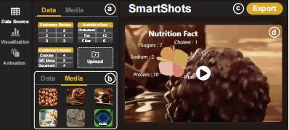

* 1. **Relevance to Course Modules**

It has two main modules:

**1.2.1 Machine Learning:** image and reorganization video moderation is done through machine learning.

**1.2.2 Data visualization:** data visualization is done by reading from database.

**1.3 Project Background**

Approximately each online shopping users feel frustrated when they have to keep scrolling to find the specific design of their needs. User also get angry when they scroll the whole site and they don’t find the desired design of specific object. This causes massive stress and constitutes a burden on the individual. Most chances are he will not visit to the website again. He will most likely want to have something that save his time and inform the customer earlier. Although extensive research has been conducted that customer need some mechanism to save their time and presentation should be according to their desire.

We have also seen that Presentation has a great impact on sales of the product many times customer complain about the presentation like the video is not good or too fast or slow etc.

**1.4 Literature Review**

Many of all other applications are develop which present the data in traditional way. No Application cares the presentation of its video according to user needs. There is no proper mechanism through which user can jump to its specific design by giving image in the search bar. Our website will address these issues.

**1.5 Analysis from Literature Review**

To develop an application, that is faster easy to use, simple, handy, effective and advanced application that is time saving and made an ease for user in every aspect to increase the sanctification ratio.

To overcome the problem of difficulty in finding the correct design quickly, we developed a website which help user to save time in finding its specific design early also video moderation happens according to user needs.

There are other applications too like “Amazon “, “Daraz” and “Ali Baba” which does not provide these functionalities to their user.

**1.6 Methodology and Software Lifecycle for This Project**

* We would be using Incremental Model because Requirements of Software are first broken down into several modules that can be incrementally constructed and delivered. At any time, the plan is made just for the next increment and not for any kind of long-term plans. Therefore, it is easier to modify the version as per the need of the customer.

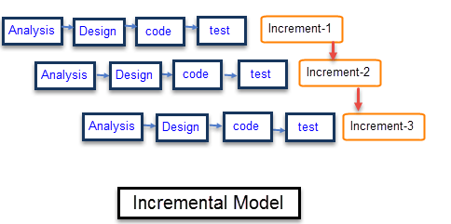

**FIGURE 1: Incremental Model**

* Once the core features are fully developed, then these are refined to increase levels of capabilities by adding new functions in Successive versions. Each incremental version is usually developed using an iterative waterfall model of development.
  + 1. **Rationale behind Selected Methodology**
* We select this methodology because our requirements are clear so through this the development will be fast and features will be added in a systematic way.
* In this methodology we will develop application through repetitive increments that in first increment we will develop interface in second increment we will add functionalities that a system will perform.

**Chapter 2**

**Problem Definition**

* 1. **Problem Statement**

As technology evolution is getting fast day by day so people are getting more dependent on technology. Technologies are moving toward Online shopping.

We see people don’t have much time to keep scrolling the shopping store to get their desired item. There is also no guarantee that the shopping site have that design to whom the user actually desires for. Video presentation is also just how seller want to show his customer which in many cases didn’t liked by the user as a result they don’t buy the product. Presentation of data related to specific product is also a challenge,

* 1. **Deliverables**

//capitalization issue

* **Website INTERFACE:** A Website will allow the user to evaluate the site in the perspective of easiness and how the application look alike.
* **Image RECOGNITION through Machine Learning:** A functionality of recognition and finding of design on the basis of provided images.
* **Project Report:** A complete Project Report that includes Software Requirements Specification, Software Design Specification, GUI Mockups, Test Cases, and other major tasks that we have performed.
* **Video moderation thrrough machine learning:** A functionality of video moderation along with the data presentation using facts in an easy way to read.
  1. **Development Requirements**

Following are the requirements which the user of the system must fulfill in order to run the system on their laptops or PCs.

## OS Requirement

## Windows operating system.

## Application Requirements

Visual studio Code, Pycharm.

**Other Requirements**

For Mockup and presentation, we use MS Word, MS Power Point, and star uml.

## Current System

## Following are the related current systems workings and are similar to our project.

## TaoBao.com

Taobao is a Chinese website that have the static data on the items.

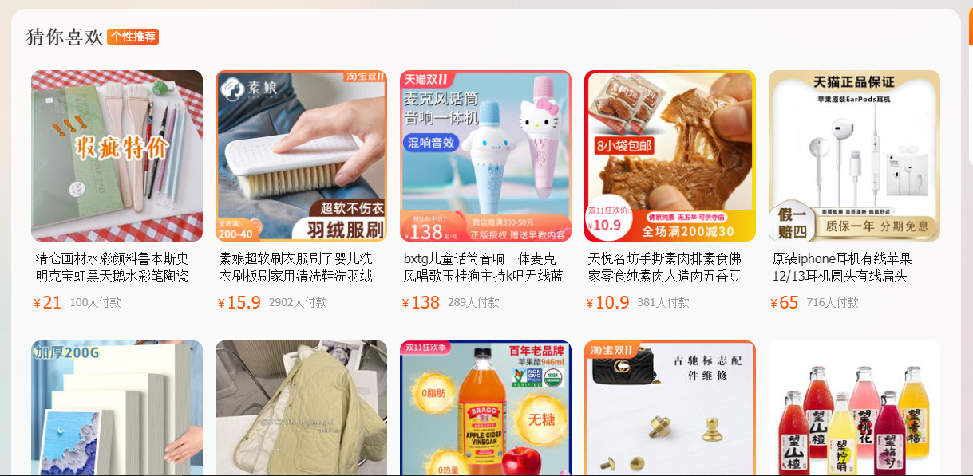

**FIGURE 2: Taobao website**

Relation with Our Application

Our application will have the display of data around the object as shown in the website.

But

Our website will be different form this site as:

1. We have the dynamic data about the object.
2. It will not be hard coded.

## Google.com

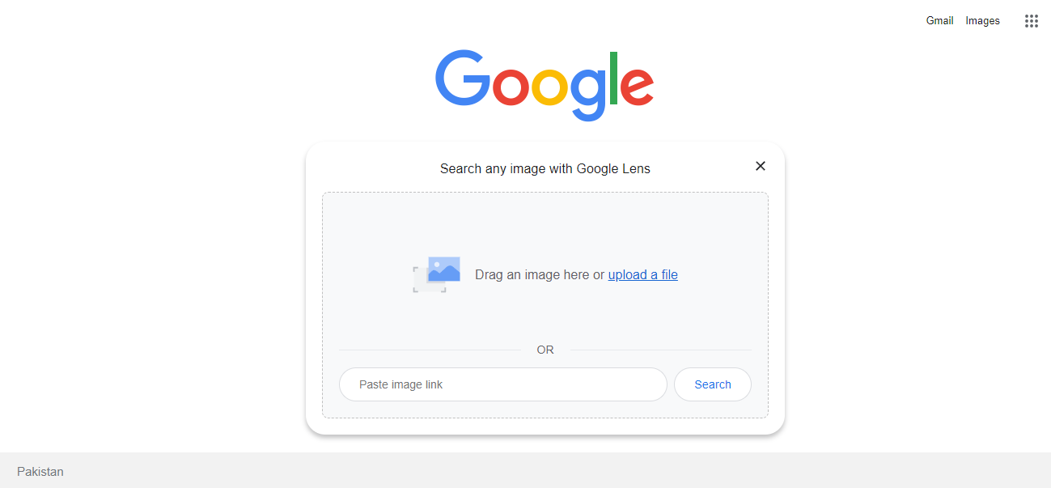

**FIGURE 3: Google Website**

Google.com is using image processing to get information of the uploaded image and provide the similar images.

**Relation with Our Application**

Our application will have the image upload option shown in the website.

But it will get the result only from our website means it will show only products if available in store.

## Chapter 3

**Requirement Analysis**

### 

### 3.1 Use Case Diagram

We are going to discuss the interaction of different actors with the proposed system, and the functional and non-functional requirements of our system. Based on these functional and non-functional requirements, we will develop our project. We will also create a use case diagram and a detailed description of those use cases. It will provide interaction between the system and user of the system.

Figure 4 is the use case diagram of our system. The user will register/login to the site.

After it he will be searching either by image upload or by typing keywords. If a customer will search with image upload image will be processed by the system and the results will be shown accordingly. Customer will get products related to that image and will order them if he wants. After that a feedback form will come which gets feedback of video moderation being used in product detail section. These feedbacks will come towards the seller and seller will be able to improve shortages.

Admin or seller is there to add products. As the owner he can make updates to the site.

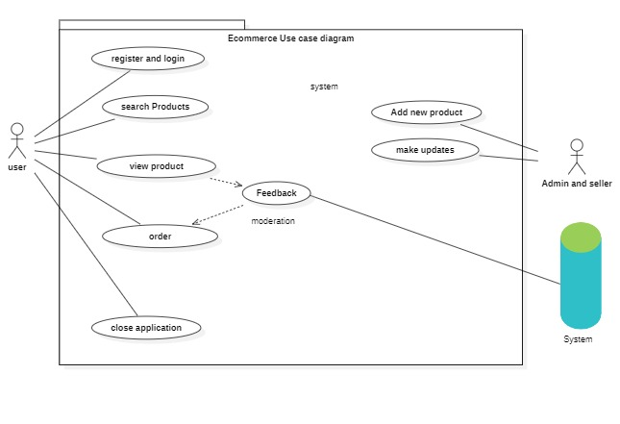

**FIGURE 4: Use Case Diagram**

### 3.2 Detailed Use Case

Use case name: Registration/login

Priority: 1

Actor: User

Summary: User must be logged in and register to perform shopping.

Pre-condition: The user must visit the website.

Post-condition: User gets logged in.

Use case name: Search product

Priority: 2

Actor: User

**Summary**: User will input image for pre-processing or type keywords.

Pre-condition: there will be option for user to upload image.

Post-condition: user will upload image.

**Use case name**: classification

Priority:3

Actor: None

**Summary**: System will take the image and classify it.

Pre-condition: System get the image.

Post-condition: products with similar design will be displayed.

**Use case name**: product display

Priority:4

Actor: None

**Summary**: classify image will be displayed.

Pre-condition: system classify image and have the result.

Post-condition: result with similar design will be displayed.

**Use case name**: Order and video feedback

Priority:5

Actor: User

**Summary**: User/customer either buy product or not also he will provide the feedback in the video display as a product overview.

Pre-condition: Result is shown to user.

Post-condition: After product is purchased, database updates the information then feedback algorithm runs to make changes accordingly for moderation purposes.

**Use case name**: Close application

Priority:6

Actor: User

**Summary**: User/customer will close the website after the task is done.

Pre-condition: feedback is given.

Post-condition: website will be closed.

**Use case name**: Add product

Priority:7

Actor: Admin

**Summary**: Admin can add product for selling.

Pre-condition: Admin must be logged in to admin dashboard for adding product.

Post-condition: Product will be added to the website.

**Use case name**: Make updates

Priority:8

Actor: Admin

**Summary**: Admin can make updates and maintain the website and resolve any issue related site.

Pre-condition: Admin must be logged in to admin dashboard for adding product.

Post-condition: changes will be applied to the website.

### 3.3 Functional Requirements

Functional requirements will tell us the behavior of our system functionalities and tasks that our system will perform. Functional requirements are those requirements that our system must do. The functional requirements of our system include Camera and PIP.

|  |  |
| --- | --- |
| Name | Image classification |
| Summary | This function is used to take image as input from user instead of typing keywords and then system will show product related to that image if available in the store. |
| Pre-Requisite | * The user should upload the clear image. * The user must follow the regulation specify to upload the image. |

#### 3.4.1 Image classification

image classification

Table 1: image classification

#### 3.4.2 Video Moderation

Video Moderation

|  |  |
| --- | --- |
| Name | Video Moderation |
| Summary | This function will provide the speed display of the video that majority of user needs. Video will consist of all the information related to products. |
| Pre-Requisite | * The user must provide feedback. * The feedback should be according to the guidelines. |

Table 2: Video Moderation

### 3.4 Non-Functional Requirements

Non-functional requirements are those requirements that specify the quality of the system. Following are the non-functional requirements of our system.

#### 3.4.1 Efficiency

Our system will be much efficient so that it will provide an accurate result.

#### 3.4.2 Learnability

Our system will be efficient and easy to understand so that novice and expert both users can use it easily.

#### 3.4.3 Robustness

Our system will be robust so that it can tolerate the faults. The system shall recover itself in less time if it is failed due to some external or internal issues.

#### 3.4.4 Maintainability

Our system will be ready to maintain and update with time. Its component will be independent and can easily be maintained.

#### 3.4.5 Reliability

Our system will recover itself in less time in case if it is failed due to some reasons. Our system will be reliable enough to use.

#### 3.4.6 Usability

Our system will be user friendly and easy to use so that user will not face any kind of difficulty while using the application.

#### 3.5.7 Availability

#### Our system will be available 24/7 so that user can use it anytime with ease.

### 3.6 Classifier CNN

In neural networks, Convolutional Neural Network (CNNs) is one of the main categories to do images recognition, images classifications. Object’s detections, recognition faces etc., are some of the areas where CNNs are widely used. The system performs the classification and predict the fruit freshness.

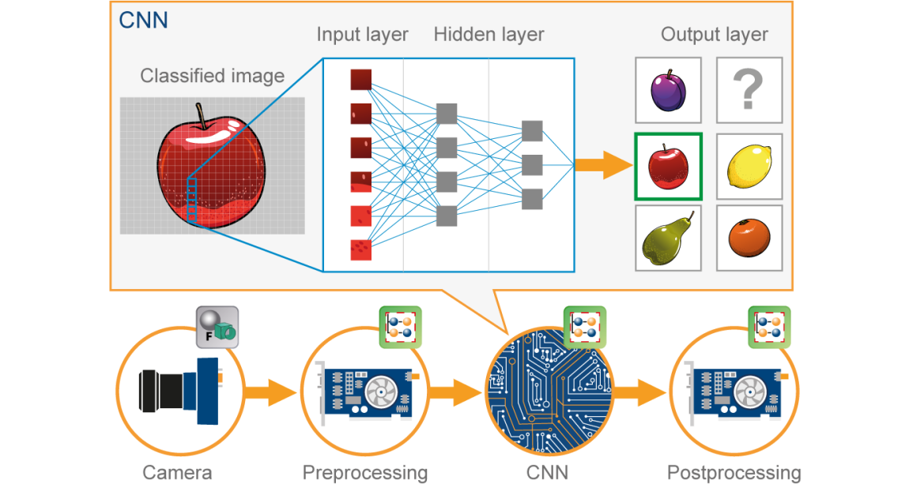

Figure 5 CNN Classification

## Chapter 4

## Design and Architecture

### 4.1 Design and Architecture

After gathering all requirements, the next step is to start planning how we are going to develop our project, how much resources, costs, time, benefits, and other items are required. Onwards we move to the designing and architecture phase that which techniques and methods we can use and how we are going to develop our project. This phase really matters while starting the development.

### 4.2 Data Representation [Diagram + Description]

Following is a data flow diagram of our system which includes level 0, level 1 and level 2 data flow diagrams of the system.

#### 4.2.1 DFD level 0

Figure 6 shows the level 0 data flow diagram of our system. The user can request the system to initialize it. The system will send a request to the camera for object detection. When the object is being detected the system will request to generate alert on Object/Obstacle Detection. The system will then alert the user about the detection of object in their way.

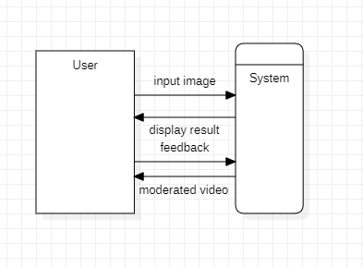

FIGURE 6: Data Flow Diagram Level 0

#### 4.2.2 DFD LEVEL 1

Figure 7 shows the data flow diagram level 1 of our system. It is more detailed than level 0. After successfully Initializing the system, the user can view the track, the process starts when the user will click on Initialize button on the application. After showing the track to the user, the user will minimize the application.

After that the backend process will start. The camera will get the video of the track and apply algorithms to detect the object. The camera will then generate the alarm on detection of any object that comes in the way and the user will be alerted of incoming object.

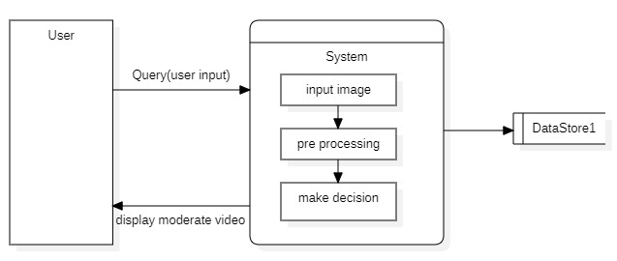

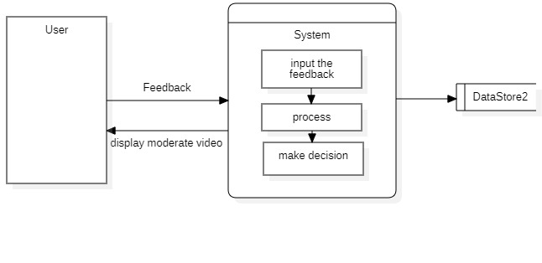

FIGURE 7: Data Flow Diagram Level 1

### 4.3 Design Models [along with descriptions]

Following are the design models of our system.

#### 4.3.1 Sequence Diagram

Figure 8 shows the sequence diagram of our system. The user will search the website.

Site will respond back if its running. User can either search product with keyword or by uploading image. If the user uploads the image, it will be processed and classify it. After that it will return the results to site. If the image is searched by keywords it will returned by products. After this data is displayed to user. When the user is leaving the site a feedback popup appear and he have to review on speed of video shown for the specific product, on the basis of that the modal will be making changes.

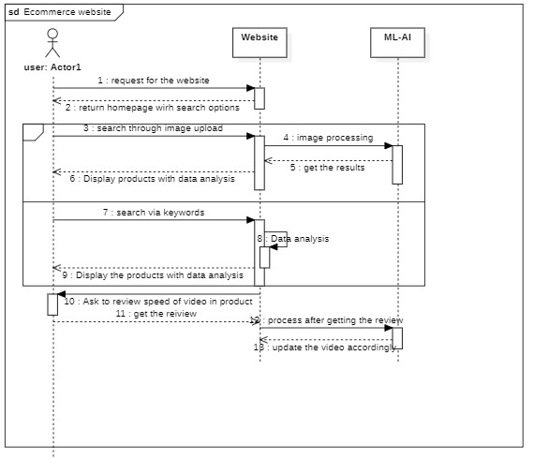

FIGURE 8: Sequence Diagram

#### 4.3.2 Activity diagram

Figure 9 shows the activity diagram of the user. User will enter the website. He will search for the product by searching or uploading the image. Then products will be displayed. He will choose the product he wants to purchase. Product video will be displayed. When user leaves the page a feedback pop up will appear. After review the user can move to website or close the site.

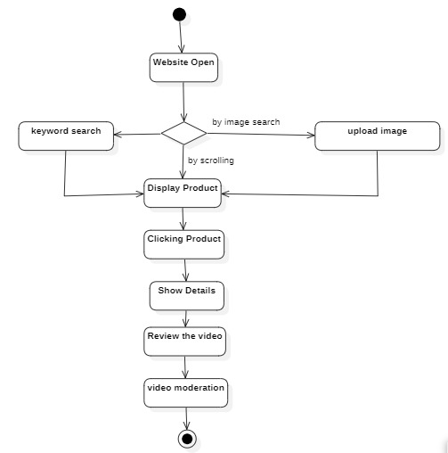

FIGURE 9: Activity Diagram